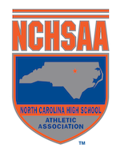

2023 NCHSAA
Polar Bear Meet Approval Form

Per the NCHSAA handbook, (4.12.3.h (2) )
Please complete this form if you are hosting a polar bear meet outdoors and the meet will have less than 5 teams participating.

This form will need to be submitted at least one (1) prior to the meet being held.

School: ______________________________
Class: _______________________________
Date of event: ________________________
Location of event: _____________________

Teams that will be participating:

1.
2.
3.
4.

Head Coach Signature: ___________________________
Athletic Director Signature: _______________________

