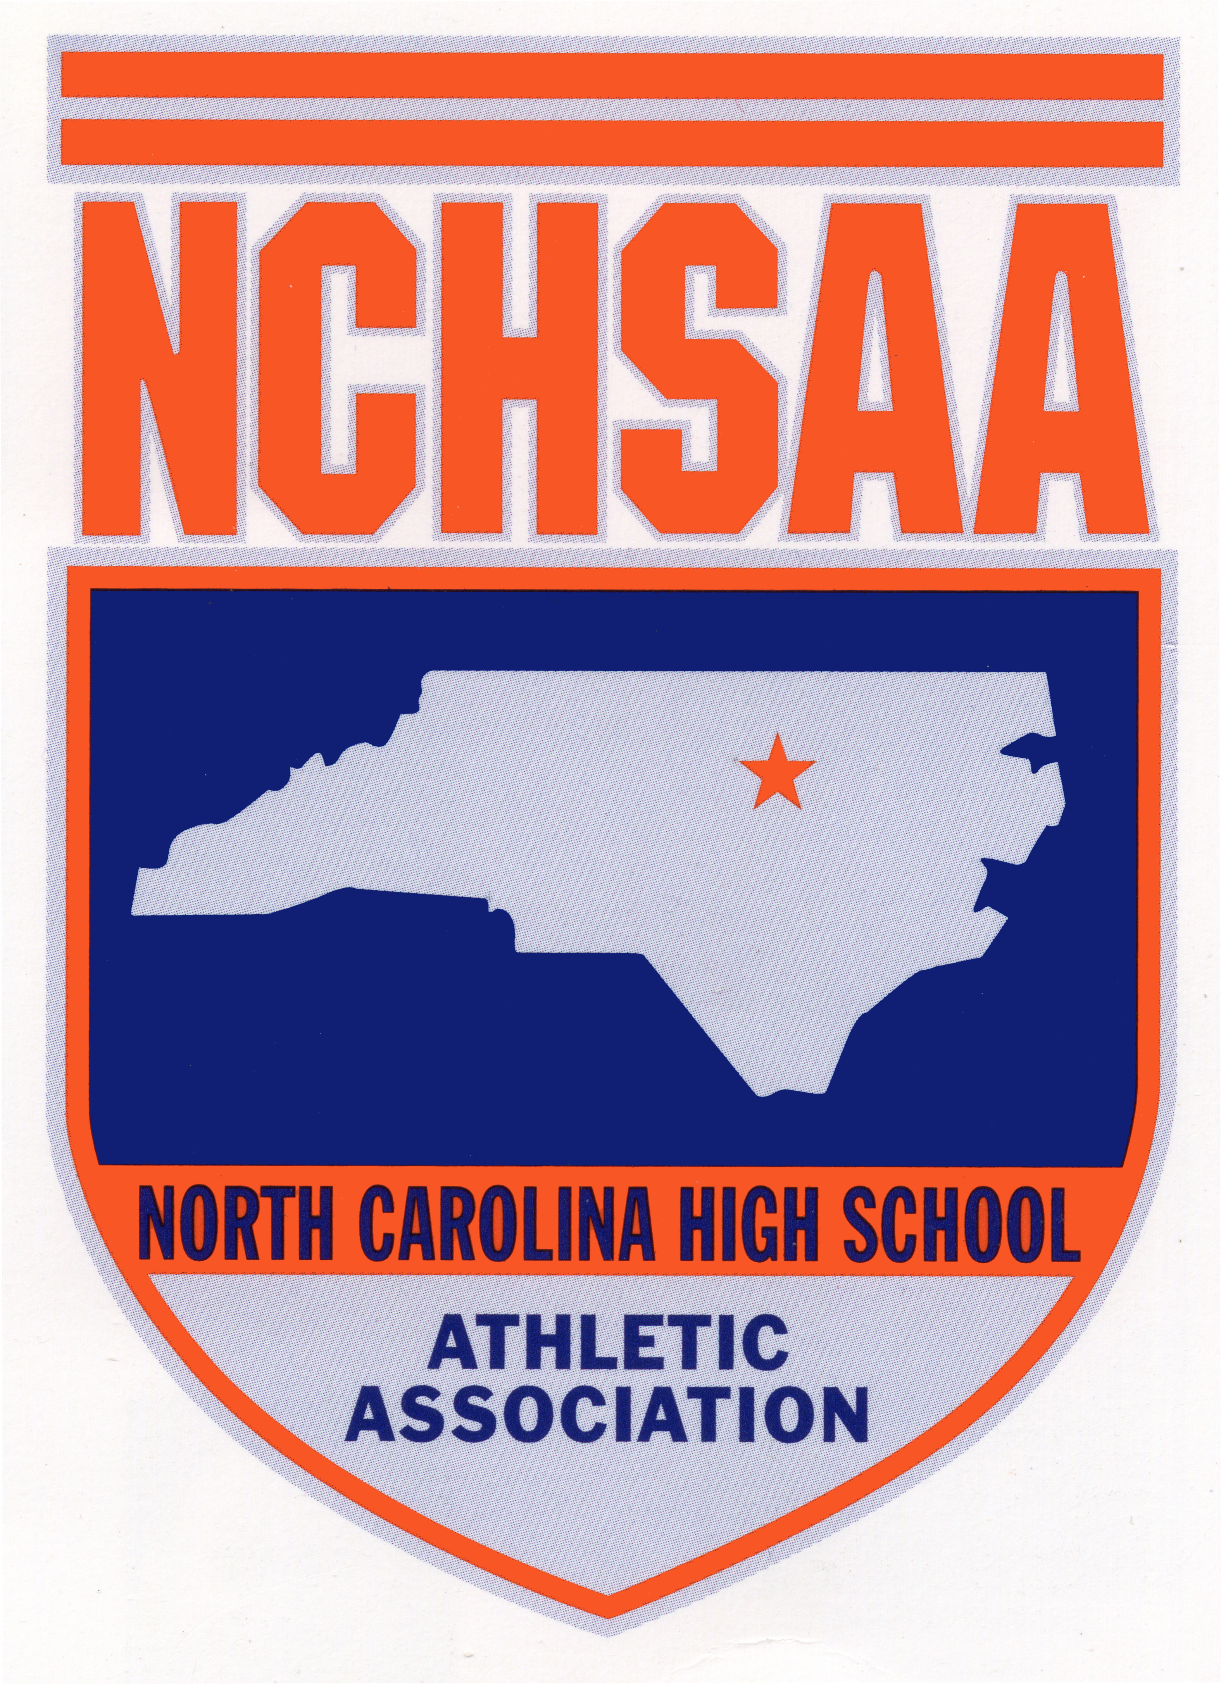
NCHSAA Declaration of Intent to Play
Lacrosse 2019-2020
Deadline: Tuesday, September 10, 2019
Email Completed Form: tra@nchsaa.org
*Complete only if adding a new team for the 2019-20 school year*

School: ______________________________________________ High School
Classification: 1A 2A 3A 4A (Circle One)
Team: Male/Female/Both (Circle One)

2017-2021 Alignment Conference: _______________________________

Principal’s Signature: _________________________________________________________
Athletic Director’s Signature: ________________________________________________

~ Use this form to declare your school’s intention of participating in the 2019-2020 NCHSAA Lacrosse Program (Including Playoffs and Championships).
~ By declaring, you are agreeing to abide by all rules and regulations put forth by the NCHSAA prior to, and during the 2019-2020 Lacrosse season.

