Emergency Action Plan for Athletic Practices/Contests

Held in Poe Gymnasium

Northern Durham High School is located at:

117 Tom Wilkinson Road

Durham, NC 27503

Phone: 000-000-0000

GPS Coordinates: (Latitude 36.094037 Longitude -78.911709)

Directions to Venue:
Enter school campus at front of school (117 Tom Wilkinson Road). Access road (highlighted in yellow) to Poe Gymnasium is located between the school’s vocational wing and the track. Parking for emergency vehicles (highlighted in yellow) is located at the main entrance to Poe Gym (north entrance).

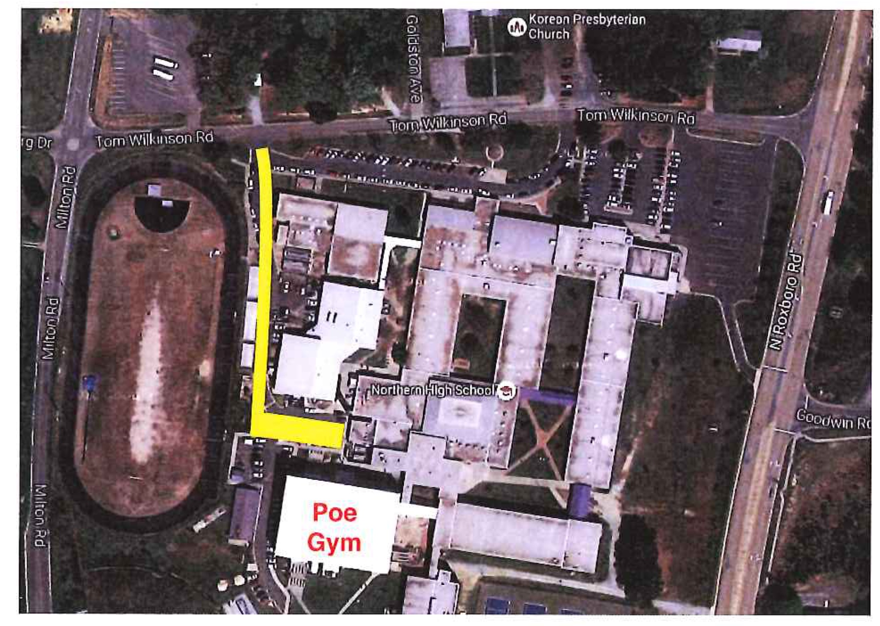

Roles Established:
(Prior to athletic events a pre-event “Time Out” should be conducted to ensure the Emergency Action Plan is reviewed and to assign roles with the personnel and equipment available for that event.)
- Immediate care of the athlete (name/title/designee)
- Activate Emergency Medical System (EMS) (name/title/designee)
- Emergency Equipment Retrieval (name/title/designee)
- Meet EMS personnel at Tom Wilkinson Road and direct them to Poe Gymnasium. (name/title/designee)
- Scene Control: Limit emergency scene to those providing first aid and move bystanders away from area. (name/title/designee)

EAP for Athletic Practices/Contests Held in Poe Gym

Page 2

Communication:
- Cell phone or landline located in Athletic Directors Office
- Activate EMS
- Student emergency information (name/title/designee)
- Critical medical information
(conditions, medications, allergies)
- Contact parent/legal custodian
- Athletic Training Staff
- Bob Foy - Head Athletic Trainer (000) 000-0000
- Cynthia Obregon-Salinas
Assistant Athletic Trainer (000) 000-0000
- Athletic Director
- Phillip Esposito (000) 000-0000

Emergency Equipment at Sport Venue:
(Events held at the venue should provide a guide as to the emergency equipment potentially needed. That emergency equipment should then be included in the Emergency Action Plan specific to that sport venue.)
- Sports Medicine First Aid Kit
- AED
- Crutch/Splint Bag
- Injury Ice
- Additional emergency equipment is available in the athletic training equipment storage area located at the Poe Gymnasium north entrance.

Emergency Transportation:
Emergency transportation vehicles will park at the main entrance to Poe Gym (north entrance). The gymnasium can then be accessed by steps or the handicapped access ramp which is located between Poe Gymnasium and the cafeteria.

Lightning or Thunder Disturbances Safe Shelter/Evacuation Route identified:
Poe Gymnasium is a designated safe shelter area in the event of lightning or thunder disturbance.
(Gymnasiums are generally not considered as safe shelters during tornadoes. You are encouraged to go here and/or here when developing a separate Tornado Preparedness Plan for your facility.)

Resources
- Casa, D.J., Almquist, J., Anderson, S.A., Baker, L., Bergeron, M.F., Biagioli, B., … Valentine, V.
(2013). The Inter-association task force for preventing sudden death in secondary school
athletics programs: Best-practices recommendations. Journal of Athletic Training, 48(4),
546-553.
- Courson, R. (2017). Emergency action plans. In D.J. Casa & R.L. Stearns (Eds.), Preventing sudden
death in sport and physical activity (pp. 271-285). Burlington, MA: Jones & Bartlett Learning.

